Challenge 1

Convert hex to base64

|  |
| --- |
| #include <stdio.h> |
|  | #include <string.h> |
|  |  |
|  | // http://cryptopals.com/sets/1/challenges/1/ |
|  |  |
|  | static const char input[] = "\x49\x27\x6d\x20\x6b\x69\x6c\x6c\x69\x6e\x67\x20\x79\x6f\x75\x72\x20\x62\x72\x61\x69\x6e\x20\x6c\x69\x6b\x65\x20\x61\x20\x70\x6f\x69\x73\x6f\x6e\x6f\x75\x73\x20\x6d\x75\x73\x68\x72\x6f\x6f\x6d"; |
|  |  |
|  | char base64_char(int val) { |
|  | switch (val) { |
|  | case 0 ... 25: return (val - 0) + 'A'; |
|  | case 26 ... 51: return (val - 26) + 'a'; |
|  | case 52 ... 61: return (val - 52) + '0'; |
|  | case 62: return '+'; |
|  | case 63: return '/'; |
|  | } |
|  | return '?'; |
|  | } |
|  |  |
|  | int main(int argc, char *argv[]) |
|  | { |
|  | int i = 0; |
|  |  |
|  | for (i = 0; i*6 < strlen(input)*8; ++i) { |
|  | const char* p = input + (i*6)/8; |
|  | char val = 0; |
|  |  |
|  | switch(i % 4) { |
|  | case 0: |
|  | val += (*p & 0xFC) >> 2; |
|  | break; |
|  | case 1: |
|  | val += (*p & 0x03) << 4; |
|  | val += *(p+1) >> 4; |
|  | break; |
|  | case 2: |
|  | val += (*p & 0x0F) << 2; |
|  | val += *(p+1) >> 6; |
|  | break; |
|  | case 3: |
|  | val += (*p & 0x3f); |
|  | val += *(p+1) >> 8; |
|  | break; |
|  | } |
|  | printf("%c", base64_char(val)); |
|  | } |
|  | printf("\n"); |
|  |  |
|  | return 0; |
|  | } |

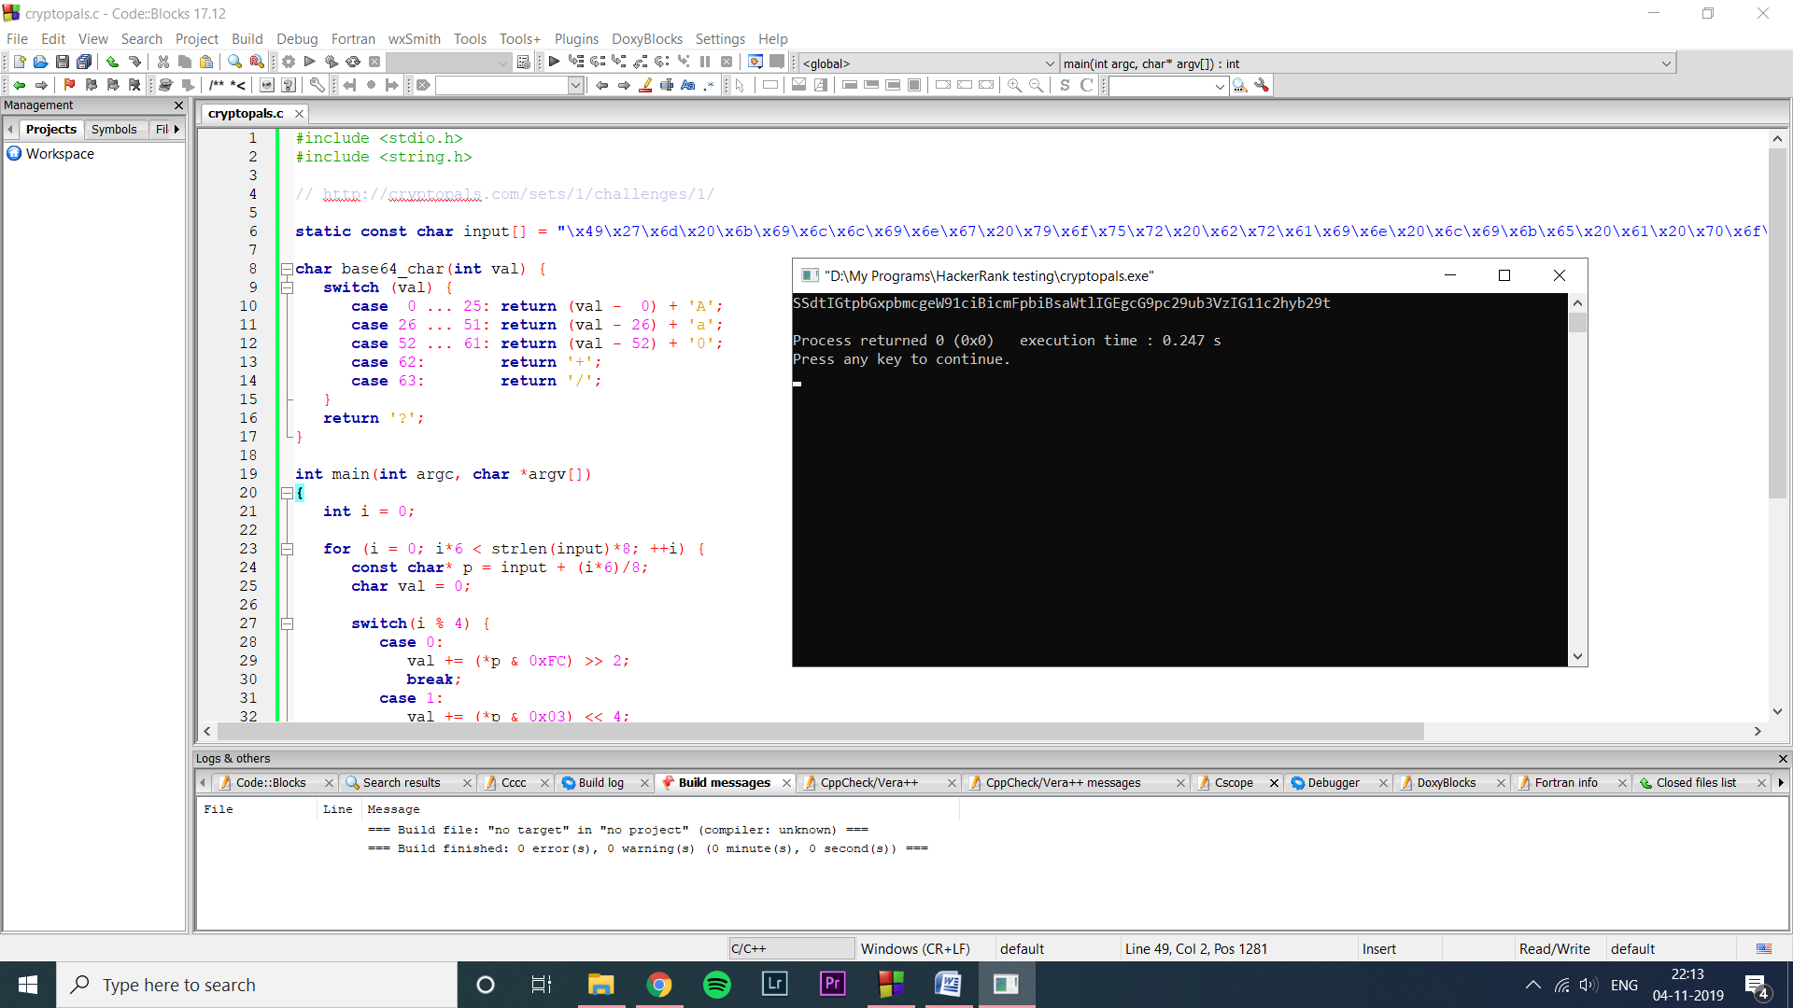

Challenge 2

Fixed XOR

|  |
| --- |
| #include <stdio.h> |
|  | #include <string.h> |
|  |  |
|  | // http://cryptopals.com/sets/1/challenges/2/ |
|  |  |
|  | static const char feed[] = "\x1c\x01\x11\x00\x1f\x01\x01\x00\x06\x1a\x02\x4b\x53\x53\x50\x09\x18\x1c"; |
|  | static const char xor[] = "\x68\x69\x74\x20\x74\x68\x65\x20\x62\x75\x6c\x6c\x27\x73\x20\x65\x79\x65"; |
|  |  |
|  | int main(int argc, char *argv[]) |
|  | { |
|  | const char* f = feed; |
|  | const char* x = xor; |
|  |  |
|  | for (; *x; ++f, ++x) { |
|  | printf("%02x", *f ^ *x); |
|  | } |
|  | printf("\n"); |
|  |  |
|  | return 0; |
|  | } |

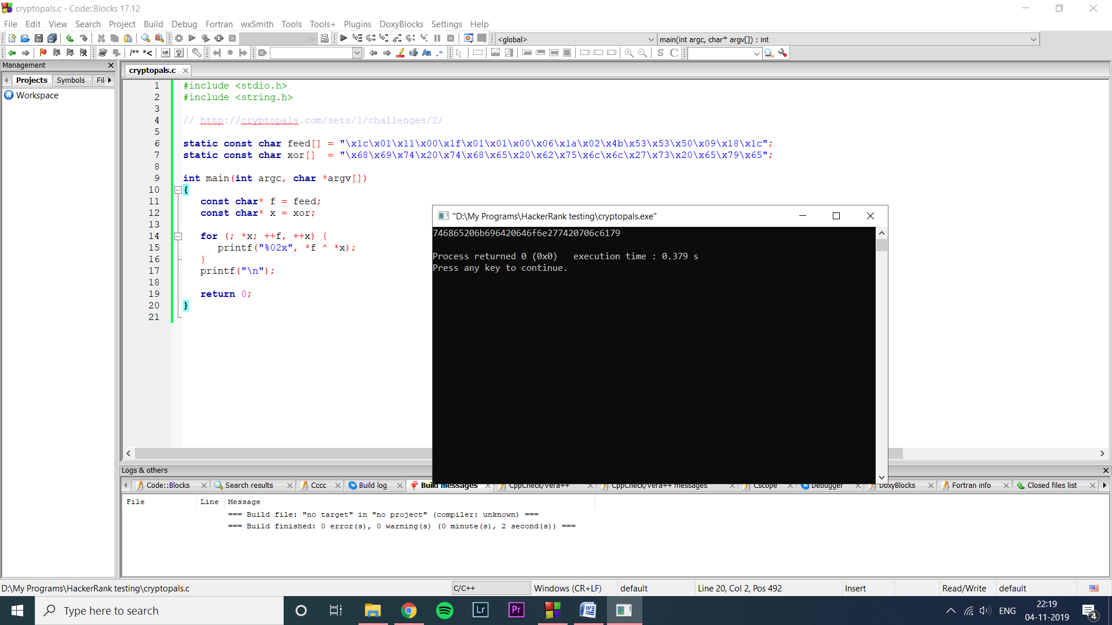

Challenge 3

Single-byte XOR cipher

|  |
| --- |
| #include <stdio.h> |
|  | #include <string.h> |
|  | #include <ctype.h> |
|  |  |
|  | // http://cryptopals.com/sets/1/challenges/3/ |
|  |  |
|  | static const char enc[] = "\x1b\x37\x37\x33\x31\x36\x3f\x78\x15\x1b\x7f\x2b\x78\x34\x31\x33\x3d\x78\x39\x78\x28\x37\x2d\x36\x3c\x78\x37\x3e\x78\x3a\x39\x3b\x37\x36"; |
|  |  |
|  | int main(int argc, char *argv[]) |
|  | { |
|  | int i = 0; |
|  | int key = 0; |
|  | int best_key = -1; |
|  | int best_score = -1; |
|  |  |
|  | for (key = 0; key <= 255; ++key) { |
|  | int score = 0; |
|  | for (i = 0; i < strlen(enc); ++i) { |
|  | char c = enc[i] ^ (char)key; |
|  | int points = 0; |
|  | switch (tolower(c)) { |
|  | case 'e': ++points; |
|  | case 't': ++points; |
|  | case 'a': ++points; |
|  | case 'o': ++points; |
|  | case 'i': ++points; |
|  | case ' ': ++points; |
|  | case 's': ++points; |
|  | case 'h': ++points; |
|  | case 'r': ++points; |
|  | case 'd': ++points; |
|  | case 'l': ++points; |
|  | case 'u': ++points; |
|  | score += points; |
|  | break; |
|  | } |
|  | } |
|  | if (score > best_score) { |
|  | best_key = key; |
|  | best_score = score; |
|  | } |
|  | } |
|  | for (i = 0; i < strlen(enc); ++i) { |
|  | printf("%c", enc[i] ^ (char)best_key); |
|  | } |
|  | printf("\n"); |
|  | return 0; |
|  | } |

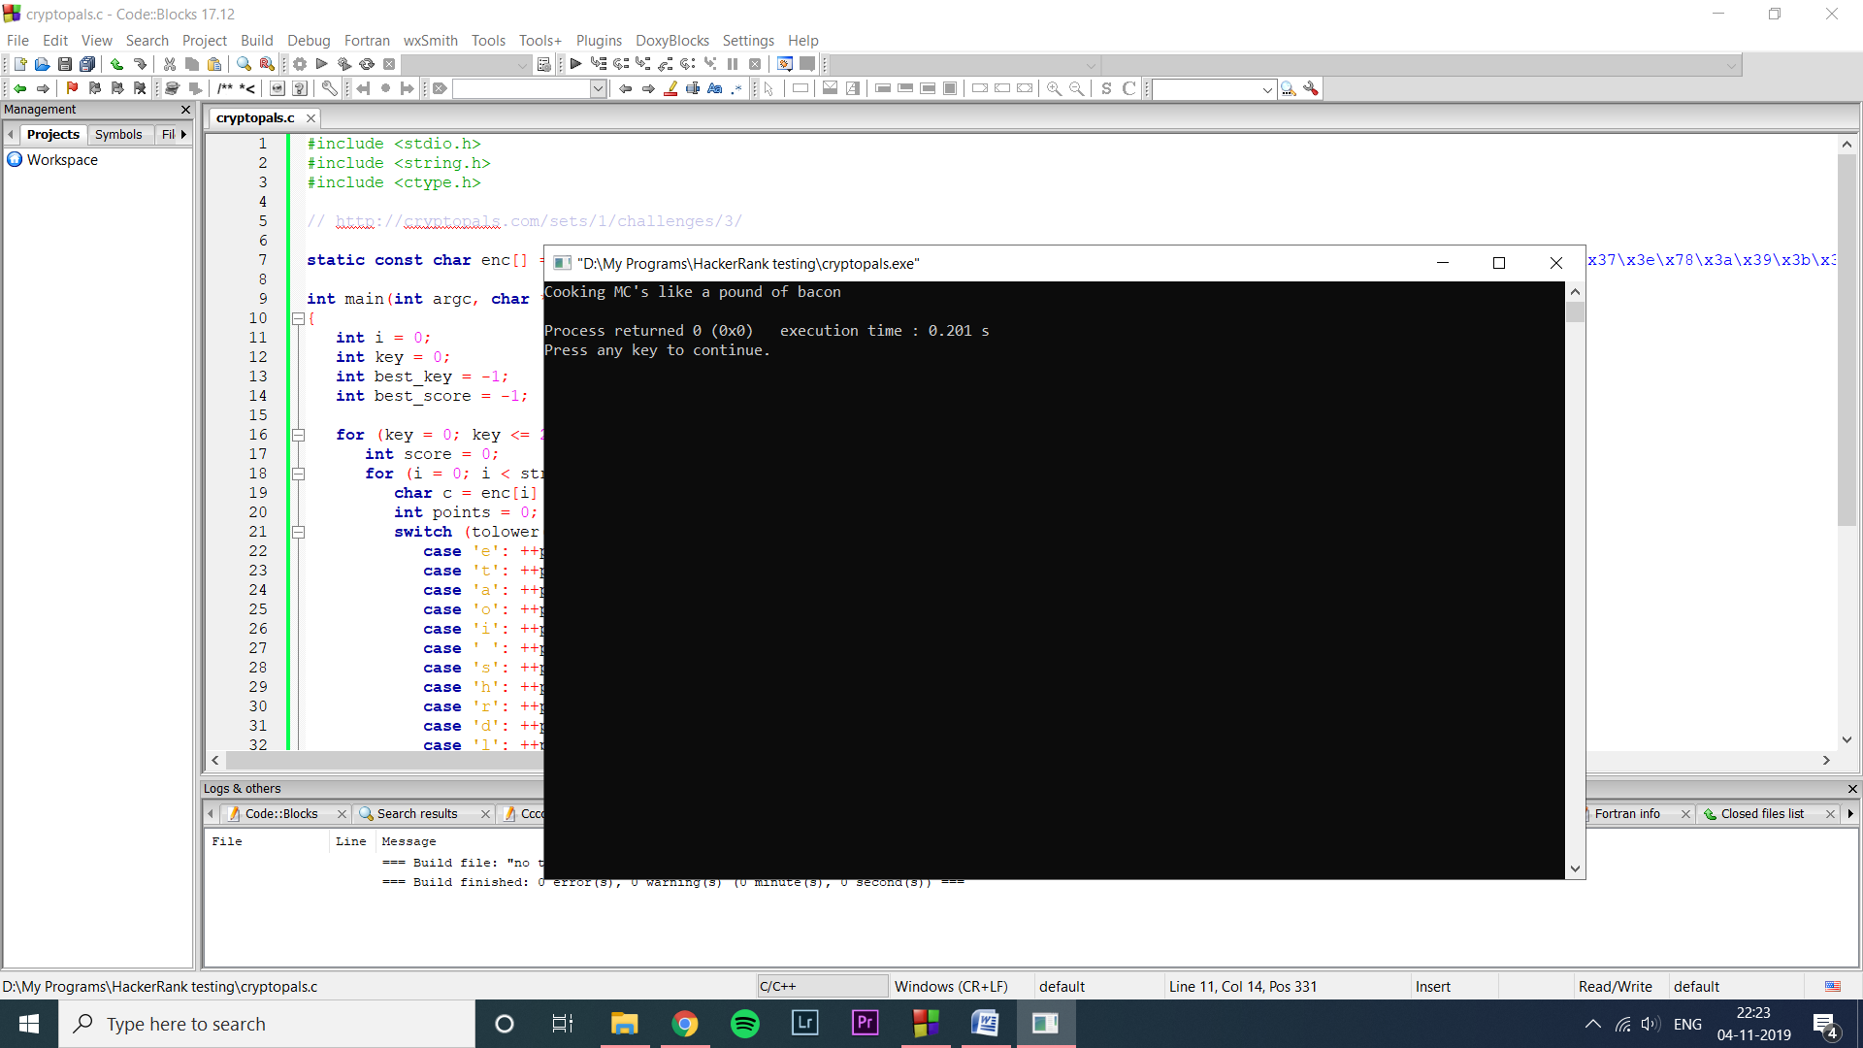

Challenge 4

Detect single-character XOR

|  |
| --- |
| #include <stdio.h> |
|  | #include <string.h> |
|  | #include <ctype.h> |
|  | #include <sys/types.h> |
|  | #include <sys/stat.h> |
|  | #include <fcntl.h> |
|  | #include <unistd.h> |
|  | #include <stdlib.h> |
|  |  |
|  | // http://cryptopals.com/sets/1/challenges/4/ |
|  |  |
|  | struct one_line { |
|  | unsigned char* pos; |
|  | size_t len; |
|  | }; |
|  |  |
|  | unsigned char hex_ascii_to_bin(unsigned char c) { |
|  | switch (c) { |
|  | case '0' ... '9' : return c - '0'; |
|  | case 'a' ... 'f' : return c - 'a' + 10; |
|  | case 'A' ... 'F' : return c - 'A' + 10; |
|  | } |
|  | return '\0'; |
|  | } |
|  |  |
|  | struct one_line* read_file(const char* filename) |
|  | { |
|  | unsigned char* data = NULL; |
|  | ssize_t total = 0; |
|  | size_t filesize = 0; |
|  | size_t lines = 0; |
|  | struct one_line* all_lines = NULL; |
|  |  |
|  | { // get file size |
|  | struct stat info; |
|  | if (stat(filename, &info)) { |
|  | printf("failed to get file info [%s]: %m\n", filename); |
|  | _exit(-1); |
|  | } |
|  | filesize = info.st_size; |
|  | } |
|  | { // allocate buffer |
|  | data = (char*)malloc(filesize); |
|  | if (!data) { |
|  | printf("failed to allocate buffer\n"); |
|  | _exit(-2); |
|  | } |
|  | } |
|  | { // read file to buffer |
|  | int fd = open(filename, O_RDONLY); |
|  | if (0 > fd) { |
|  | printf("failed to open file [%s]: %m\n", filename); |
|  | _exit(-3); |
|  | } |
|  | while (total < (ssize_t)filesize) { |
|  | ssize_t now = read(fd, &data[total], filesize - total); |
|  | if (0 > now) { |
|  | printf("error while reading from file [%s]: %m\n", filename); |
|  | _exit(-3); |
|  | } |
|  | if (0 == now) { |
|  | printf("end-of-file [%s]\n"); |
|  | break; |
|  | } |
|  | total += now; |
|  | } |
|  | close(fd); |
|  | } |
|  | { // count lines |
|  | char* p = data; |
|  | for (lines = 0; (p = strchr(p, '\n')); ++lines, ++p) {} |
|  | } |
|  | { // allocate Lines buffer |
|  | all_lines = (struct one_line*)malloc(sizeof(struct one_line) * (lines + 1)); |
|  | if (!all_lines) { |
|  | printf("failed to allocate lines\n"); |
|  | _exit(-3); |
|  | } |
|  | } |
|  | { // store lines |
|  | size_t i = 0; |
|  | unsigned char c = 0; |
|  | size_t pos = 0; |
|  | struct one_line* this_line = all_lines; |
|  | this_line->pos = data; |
|  |  |
|  | // walk the buffer |
|  | for (i = 0, pos = 0; i < filesize; ++i) { |
|  | // on newline, end this line, start a new one |
|  | if ('\n' == data[i]) { |
|  | this_line->len = &data[pos] - this_line->pos; |
|  | ++this_line; |
|  | this_line->pos = &data[pos]; |
|  | continue; |
|  | } |
|  | // otherwise convert ascii hex to bin hex |
|  | if (i % 2) { |
|  | c += hex_ascii_to_bin(data[i]); |
|  | data[pos] = c; |
|  | ++pos; |
|  | continue; |
|  | } |
|  | c = hex_ascii_to_bin(data[i]) << 4; |
|  | } |
|  | this_line->pos = 0; // terminator |
|  | this_line->len = 0; // |
|  | } |
|  | return all_lines; |
|  | } |
|  |  |
|  | int main(int argc, char *argv[]) |
|  | { |
|  | int i = 0; |
|  | int j = 0; |
|  | int best_line = -1; |
|  | int best_key = -1; |
|  | int best_score = -1; |
|  | int best_input = -1; |
|  | struct one_line* lines = read_file("4.txt"); |
|  |  |
|  | for (j = 0; (lines[j].pos && lines[j].len); ++j) { |
|  | int key = 0; |
|  | for (key = 0; key <= 255; ++key) { |
|  | int score = 0; |
|  | for (i = 0; i < lines[j].len; ++i) { |
|  | char c = lines[j].pos[i] ^ (char)key; |
|  | int points = 0; |
|  | switch (tolower(c)) { |
|  | case 'e': ++points; |
|  | case 't': ++points; |
|  | case 'a': ++points; |
|  | case 'o': ++points; |
|  | case 'i': ++points; |
|  | case ' ': ++points; |
|  | case 's': ++points; |
|  | case 'h': ++points; |
|  | case 'r': ++points; |
|  | case 'd': ++points; |
|  | case 'l': ++points; |
|  | case 'u': ++points; |
|  | score += points; |
|  | break; |
|  | } |
|  | } |
|  | if (score > best_score) { |
|  | best_line = j; |
|  | best_key = key; |
|  | best_score = score; |
|  | } |
|  | } |
|  | } |
|  | // printf("best line %d best key %d\n", best_line, best_key); |
|  | for (i = 0; i < lines[best_line].len; ++i) { |
|  | printf("%c", lines[best_line].pos[i] ^ (char)best_key); |
|  | // printf("%02x", lines[best_line].pos[i]); |
|  | } |
|  | printf("\n"); |
|  |  |
|  | return 0; |
|  | } |

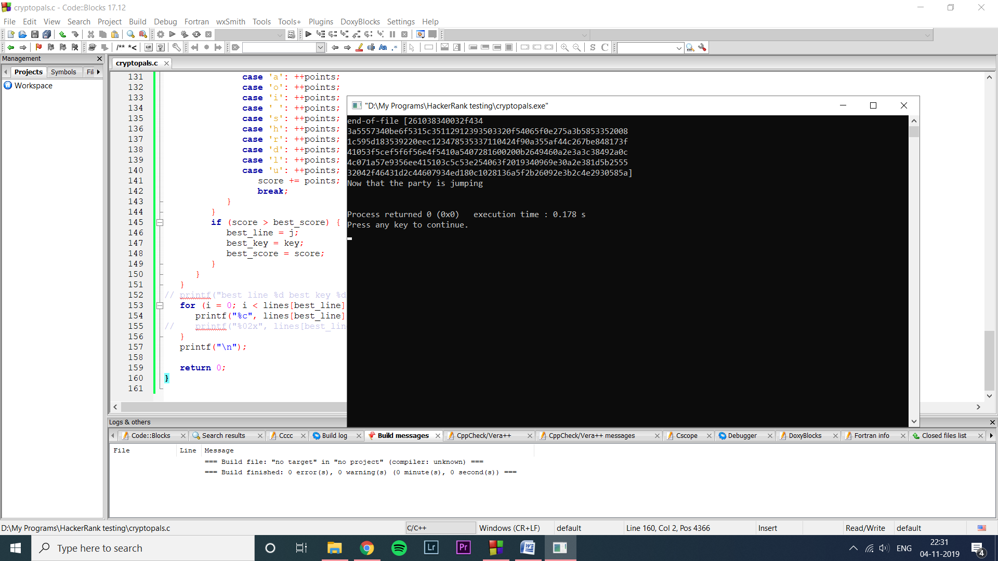

Challenge 5

Implement repeating-key XOR

|  |
| --- |
| #include <stdio.h> |
|  | #include <string.h> |
|  | #include <ctype.h> |
|  | #include <sys/types.h> |
|  | #include <sys/stat.h> |
|  | #include <fcntl.h> |
|  | #include <unistd.h> |
|  | #include <stdlib.h> |
|  |  |
|  | // http://cryptopals.com/sets/1/challenges/5/ |
|  |  |
|  | const char const key[] = "ICE"; |
|  |  |
|  | void read_and_encrypt_file(const char* filename) |
|  | { |
|  | unsigned char* data = NULL; |
|  | int fd = -1; |
|  | size_t key_index = 0; |
|  | ssize_t ret = 0; |
|  |  |
|  | // allocate buffer |
|  | data = (char*)malloc(512); |
|  | if (!data) { |
|  | printf("failed to allocate buffer\n"); |
|  | _exit(-2); |
|  | } |
|  | // read file to buffer |
|  | fd = open(filename, O_RDONLY); |
|  | if (0 > fd) { |
|  | printf("failed to open file [%s]: %m\n", filename); |
|  | _exit(-3); |
|  | } |
|  | while (ret = read(fd, data, 512)) { |
|  | int i = 0; |
|  | if (0 > ret) { |
|  | printf("error while reading from file [%s]: %m\n", filename); |
|  | _exit(-3); |
|  | } |
|  | for (i = 0; i < ret; ++i) { |
|  | printf("%02x", data[i] ^ key[key_index]); |
|  | ++key_index; |
|  | key_index %= strlen(key); |
|  | } |
|  | } |
|  | close(fd); |
|  | printf("\n"); |
|  | } |
|  |  |
|  | int main(int argc, char *argv[]) |
|  | { |
|  | const char* file = NULL; |
|  | if (2 <= argc) { |
|  | file = argv[1]; |
|  | } |
|  | else { |
|  | file = "5.txt"; |
|  | } |
|  | read_and_encrypt_file(file); |
|  |  |
|  | return 0; |
|  | } |

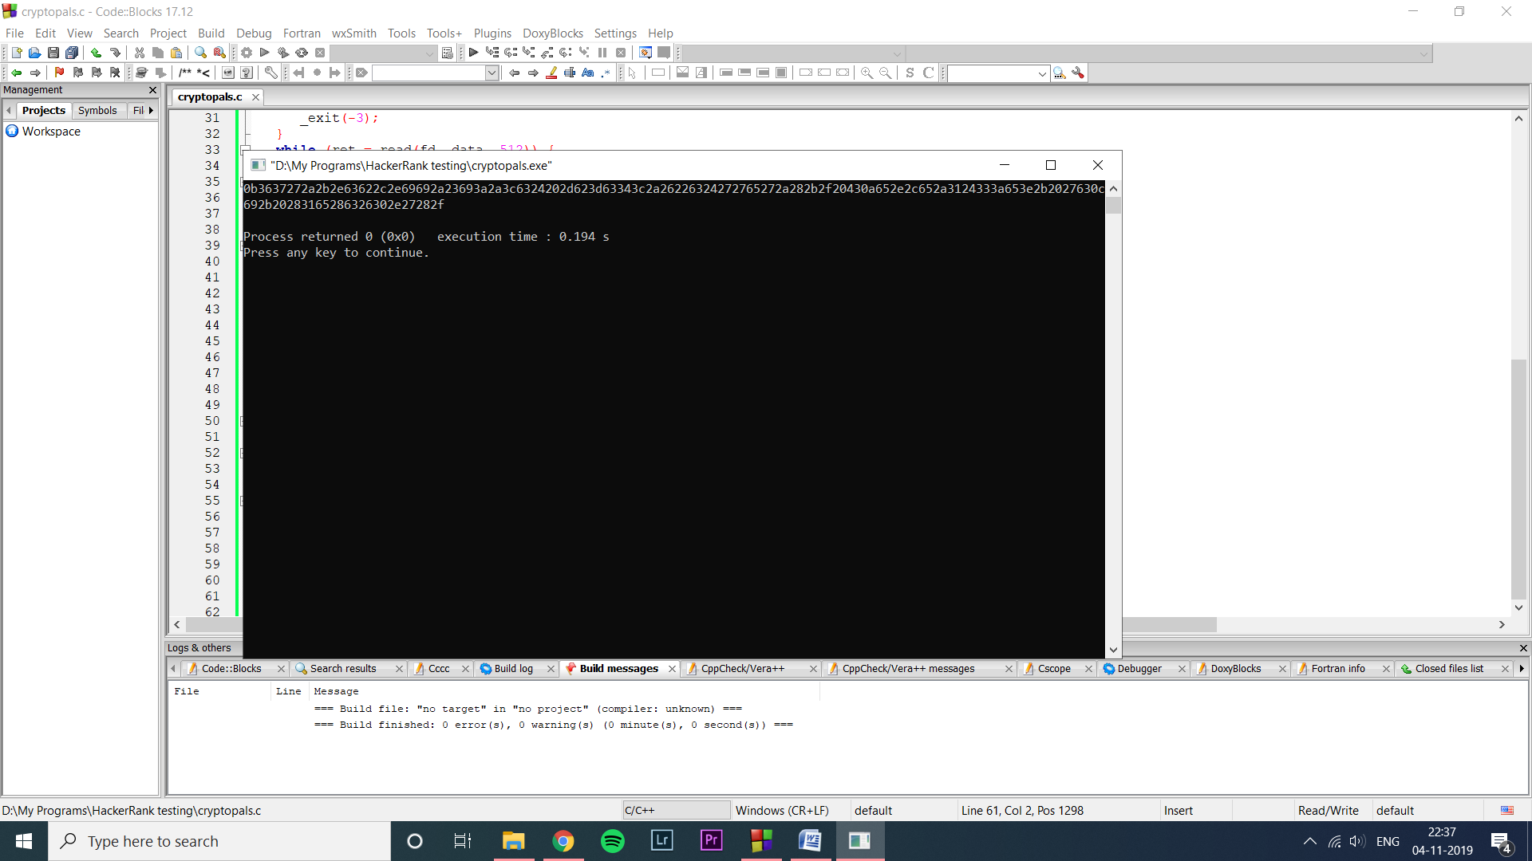

Challenge 6

Break repeating-key XOR

|  |
| --- |
| #include <stdio.h> |
|  | #include <string.h> |
|  | #include <ctype.h> |
|  | #include <sys/types.h> |
|  | #include <sys/stat.h> |
|  | #include <fcntl.h> |
|  | #include <unistd.h> |
|  | #include <stdlib.h> |
|  |  |
|  | // http://cryptopals.com/sets/1/challenges/6/ |
|  |  |
|  | unsigned char hex_ascii_to_bin(unsigned char c) { |
|  | switch (c) { |
|  | case '0' ... '9' : return c - '0'; |
|  | case 'a' ... 'f' : return c - 'a' + 10; |
|  | case 'A' ... 'F' : return c - 'A' + 10; |
|  | } |
|  | return '\0'; |
|  | } |
|  |  |
|  | unsigned char* read_file(const char* filename, size_t* len) |
|  | { |
|  | unsigned char* data = NULL; |
|  | ssize_t total = 0; |
|  | size_t filesize = 0; |
|  |  |
|  | { // get file size |
|  | struct stat info; |
|  | if (stat(filename, &info)) { |
|  | printf("failed to get file info [%s]: %m\n", filename); |
|  | _exit(-1); |
|  | } |
|  | filesize = info.st_size; |
|  | } |
|  | { // allocate buffer |
|  | data = (char*)malloc(filesize); |
|  | if (!data) { |
|  | printf("failed to allocate buffer\n"); |
|  | _exit(-2); |
|  | } |
|  | } |
|  | { // read file to buffer |
|  | int fd = open(filename, O_RDONLY); |
|  | if (0 > fd) { |
|  | printf("failed to open file [%s]: %m\n", filename); |
|  | _exit(-3); |
|  | } |
|  | while (total < (ssize_t)filesize) { |
|  | ssize_t now = read(fd, &data[total], filesize - total); |
|  | if (0 > now) { |
|  | printf("error while reading from file [%s]: %m\n", filename); |
|  | _exit(-3); |
|  | } |
|  | if (0 == now) { |
|  | printf("end-of-file [%s]\n"); |
|  | break; |
|  | } |
|  | total += now; |
|  | } |
|  | *len = (size_t)total; |
|  | close(fd); |
|  | } |
|  | return data; |
|  | } |
|  |  |
|  | char char_to_base64(int val) { |
|  | switch (val) { |
|  | case 'A' ... 'Z': return (val + 0) - 'A'; |
|  | case 'a' ... 'z': return (val + 26) - 'a'; |
|  | case '0' ... '9': return (val + 52) - '0'; |
|  | case '+': return 62; |
|  | case '/': return 63; |
|  | } |
|  | return 0; |
|  | } |
|  |  |
|  | void base64_to_bin(unsigned char* data, size_t *len) |
|  | { |
|  | size_t i = 0; |
|  | size_t j = 0; |
|  | unsigned int c = 0; |
|  | size_t shift = 3; |
|  |  |
|  | // walk the buffer |
|  | for (i = 0; i < *len; ++i) { |
|  | // skip newlines |
|  | if ('\n' == data[i]) { |
|  | continue; |
|  | } |
|  | // convert base64 to bin hex |
|  | c += char_to_base64(data[i]) << (6 * shift); |
|  | if (0 == shift) { |
|  | data[j++] = c >> (2 * 8); |
|  | data[j++] = c >> (1 * 8); |
|  | data[j++] = c >> (0 * 8); |
|  | shift = 3; |
|  | c = 0; |
|  | } else { |
|  | --shift; |
|  | } |
|  | } |
|  | *len = j; |
|  | } |
|  |  |
|  | size_t hamming_distance(const unsigned char* a, const unsigned char* b, size_t len) |
|  | { |
|  | size_t dist = 0; |
|  | size_t i = 0; |
|  | for (i = 0; i < len; ++i) { |
|  | unsigned char c = a[i] ^ b[i]; |
|  | while (c) { |
|  | if (c & 0x01) { ++dist; } |
|  | c = (c & 0xff) >> 1; |
|  | } |
|  | } |
|  | return dist; |
|  | } |
|  |  |
|  | size_t find_best_key_size(unsigned char* data, size_t data_len) |
|  | { |
|  | size_t best_size = 0; |
|  | size_t best_score = 1000000; |
|  | int key = 0; |
|  |  |
|  | for (key = 2; key <= 40; ++key) { |
|  | int i = 0; |
|  | size_t score = 0; |
|  | for (i = 0; i < 10; ++i) { // do the test twice |
|  | score += hamming_distance(&data[i*key], &data[(i+1)*key], key); |
|  | } |
|  | score = score * 10000 / key; // normalize |
|  | //printf("score for key %d is %d\n", key, score); |
|  | if (score < best_score) { |
|  | best_score = score; |
|  | best_size = key; |
|  | } |
|  | } |
|  | //printf("found best key length %d with score %d\n", best_size, best_score); |
|  | return best_size; |
|  | } |
|  |  |
|  | int score_for_char(char c) |
|  | { |
|  | int points = 0; |
|  | switch (tolower(c)) { |
|  | case 'e': ++points; |
|  | case 't': ++points; |
|  | case 'a': ++points; |
|  | case 'o': ++points; |
|  | case 'i': ++points; |
|  | case ' ': ++points; |
|  | case 's': ++points; |
|  | case 'h': ++points; |
|  | case 'r': ++points; |
|  | case 'd': ++points; |
|  | case 'l': ++points; |
|  | case 'u': ++points; |
|  | break; |
|  | // case 0x80 ... 0xff: points = -1; |
|  | } |
|  | return points; |
|  | } |
|  |  |
|  | void calculate_key(const unsigned char* data, size_t data_len, unsigned char* key, size_t key_len) |
|  | { |
|  | int i = 0; |
|  |  |
|  | for (i = 0; i < key_len; ++i) { |
|  | // calculate single byte at 'i' |
|  | unsigned char best_byte = 0; |
|  | int best_score = 0; |
|  | int byte = 0; |
|  | for (byte = 0; byte <= 255; ++byte) { |
|  | int j = 0; |
|  | int score = 0; |
|  | for (j = i; j < data_len; j += key_len) { |
|  | score += score_for_char(data[j] ^ (unsigned char)byte); |
|  | } |
|  | if (score > best_score) { |
|  | best_score = score; |
|  | best_byte = byte; |
|  | } |
|  | } |
|  | key[i] = best_byte; |
|  | //printf("best byte for %d is 0x%02x with score %d\n", i, best_byte, best_score); |
|  | } |
|  | } |
|  |  |
|  | void decrypt_repeated_key(const unsigned char* data, size_t data_len, unsigned char* key, size_t key_size) |
|  | { |
|  | size_t i = 0; |
|  | size_t k = 0; |
|  | for (i = 0; i < data_len; ++i) { |
|  | printf("%c", data[i] ^ key[k]); |
|  | ++k; |
|  | k %= key_size; |
|  | } |
|  | } |
|  |  |
|  | int main(int argc, char *argv[]) |
|  | { |
|  | size_t data_len = 0; |
|  | unsigned char* data = NULL; |
|  | size_t key_size = 0; |
|  | unsigned char* key = NULL; |
|  |  |
|  | { // test Hamming distance |
|  | const char a[] = "this is a test"; |
|  | const char b[] = "wokka wokka!!!"; |
|  | size_t dist = hamming_distance(a, b, strlen(a)); |
|  | if (37 != dist) { |
|  | printf("Hamming #define istance %d is not 37\n", dist); |
|  | _exit(-1); |
|  | } |
|  | } |
|  |  |
|  | // read file to buffer |
|  | data = read_file("6.txt", &data_len); |
|  |  |
|  | // convert base64 to binary data |
|  | base64_to_bin(data, &data_len); |
|  |  |
|  | // find best key size |
|  | key_size = find_best_key_size(data, data_len); |
|  |  |
|  | // calculate key |
|  | key = (unsigned char*)malloc(key_size); |
|  | calculate_key(data, data_len, key, key_size); |
|  |  |
|  | // decrypt |
|  | decrypt_repeated_key(data, data_len, key, key_size); |
|  |  |
|  | printf("\n"); |
|  |  |
|  | // TODO free buffers |
|  | return 0; |
|  | } |

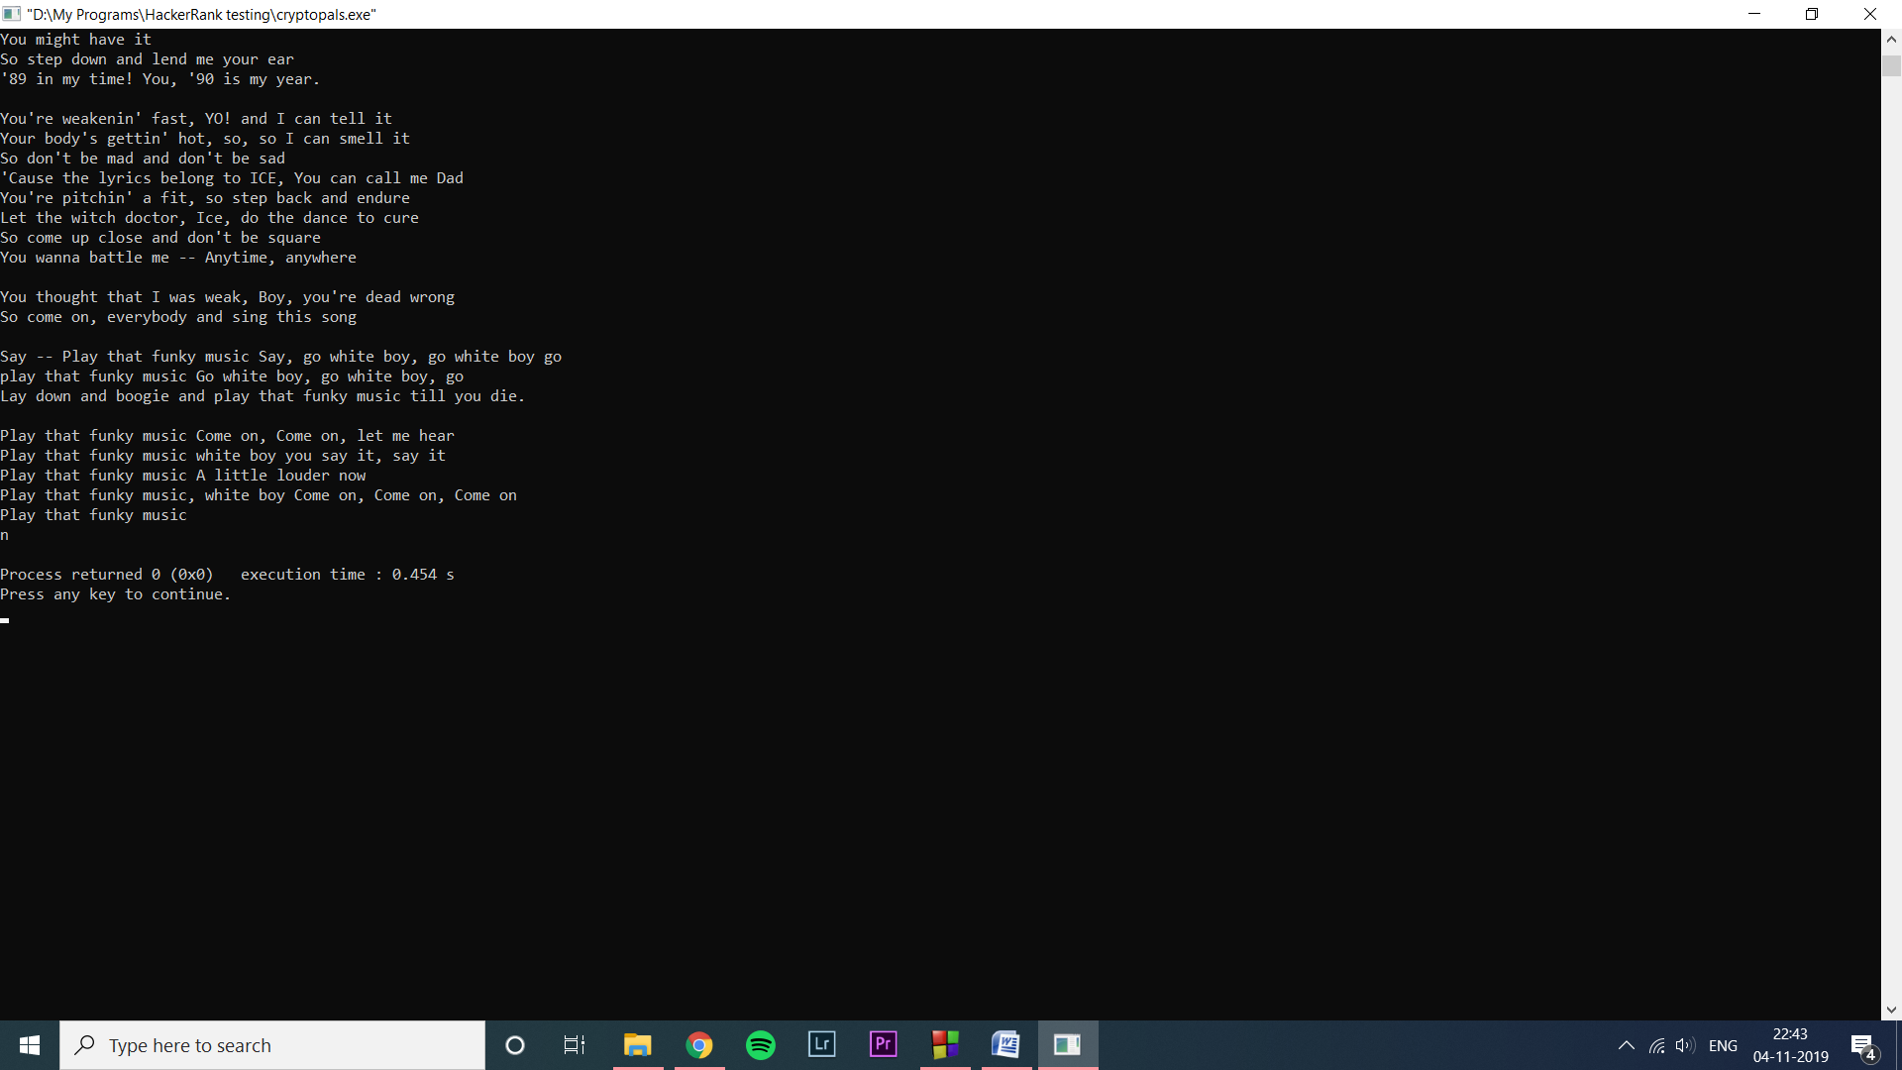

Challenge 7

AES in ECB mode

|  |
| --- |
| #include <stdio.h> |
|  | #include <string.h> |
|  | #include <ctype.h> |
|  | #include <sys/types.h> |
|  | #include <sys/stat.h> |
|  | #include <fcntl.h> |
|  | #include <unistd.h> |
|  | #include <stdlib.h> |
|  |  |
|  | #include <polarssl/aes.h> |
|  |  |
|  | // http://cryptopals.com/sets/1/challenges/7/ |
|  |  |
|  | unsigned char* read_file(const char* filename, size_t* len) |
|  | { |
|  | unsigned char* data = NULL; |
|  | ssize_t total = 0; |
|  | size_t filesize = 0; |
|  |  |
|  | { // get file size |
|  | struct stat info; |
|  | if (stat(filename, &info)) { |
|  | printf("failed to get file info [%s]: %m\n", filename); |
|  | _exit(-1); |
|  | } |
|  | filesize = info.st_size; |
|  | } |
|  | { // allocate buffer |
|  | data = (char*)malloc(filesize); |
|  | if (!data) { |
|  | printf("failed to allocate buffer\n"); |
|  | _exit(-2); |
|  | } |
|  | } |
|  | { // read file to buffer |
|  | int fd = open(filename, O_RDONLY); |
|  | if (0 > fd) { |
|  | printf("failed to open file [%s]: %m\n", filename); |
|  | _exit(-3); |
|  | } |
|  | while (total < (ssize_t)filesize) { |
|  | ssize_t now = read(fd, &data[total], filesize - total); |
|  | if (0 > now) { |
|  | printf("error while reading from file [%s]: %m\n", filename); |
|  | _exit(-3); |
|  | } |
|  | if (0 == now) { |
|  | printf("end-of-file [%s]\n"); |
|  | break; |
|  | } |
|  | total += now; |
|  | } |
|  | *len = (size_t)total; |
|  | close(fd); |
|  | } |
|  | return data; |
|  | } |
|  |  |
|  | char char_to_base64(int val) { |
|  | switch (val) { |
|  | case 'A' ... 'Z': return (val + 0) - 'A'; |
|  | case 'a' ... 'z': return (val + 26) - 'a'; |
|  | case '0' ... '9': return (val + 52) - '0'; |
|  | case '+': return 62; |
|  | case '/': return 63; |
|  | } |
|  | return 0; |
|  | } |
|  |  |
|  | void base64_to_bin(unsigned char* data, size_t *len) |
|  | { |
|  | size_t i = 0; |
|  | size_t j = 0; |
|  | unsigned int c = 0; |
|  | size_t shift = 3; |
|  |  |
|  | // walk the buffer |
|  | for (i = 0; i < *len; ++i) { |
|  | // skip newlines |
|  | if ('\n' == data[i]) { |
|  | continue; |
|  | } |
|  | // convert base64 to bin hex |
|  | c += char_to_base64(data[i]) << (6 * shift); |
|  | if (0 == shift) { |
|  | data[j++] = c >> (2 * 8); |
|  | data[j++] = c >> (1 * 8); |
|  | data[j++] = c >> (0 * 8); |
|  | shift = 3; |
|  | c = 0; |
|  | } else { |
|  | --shift; |
|  | } |
|  | } |
|  | *len = j; |
|  | } |
|  |  |
|  | void decrypt_aes_ecb(unsigned char* data, size_t data_len, unsigned char* key, size_t key_len) |
|  | { |
|  | int ret = 0; |
|  | aes_context ctx; |
|  | unsigned char decr[16]; |
|  | int i = 0; |
|  |  |
|  | ret = aes_setkey_dec(&ctx, key, key_len*8); // length in bits |
|  | if (ret) { |
|  | printf("invalid AES key length %d\n", key_len); |
|  | _exit(-20); |
|  | } |
|  | for (i = 0; i < data_len; i += 16) { |
|  | int j = 0; |
|  | ret = aes_crypt_ecb(&ctx, AES_DECRYPT, &data[i], decr); |
|  | if (ret) { |
|  | printf("failed to decrypt\n"); |
|  | _exit(-21); |
|  | } |
|  | for (j = 0; j < 16; ++j) { |
|  | printf("%c", decr[j]); |
|  | } |
|  | } |
|  | } |
|  |  |
|  | int main(int argc, char *argv[]) |
|  | { |
|  | size_t data_len = 0; |
|  | unsigned char* data = NULL; |
|  | unsigned char key[] = "YELLOW SUBMARINE"; |
|  |  |
|  | // read file to buffer |
|  | data = read_file("7.txt", &data_len); |
|  |  |
|  | // convert base64 to binary data |
|  | base64_to_bin(data, &data_len); |
|  |  |
|  | // decrypt |
|  | decrypt_aes_ecb(data, data_len, key, sizeof(key)-1 ); |
|  |  |
|  | printf("\n"); |
|  |  |
|  | // TODO free buffers |
|  | return 0; |
|  | } |

Decrypted text

I'm back and I'm ringin' the bell A rockin' on the mike while the fly girls yell In ecstasy in the back of me Well that's my DJ Deshay cuttin' all them Z's Hittin' hard and the girlies goin' crazy Vanilla's on the mike, man I'm not lazy. I'm lettin' my drug kick in It controls my mouth and I begin To just let it flow, let my concepts go My posse's to the side yellin', Go Vanilla Go! Smooth 'cause that's the way I will be And if you don't give a damn, then Why you starin' at me So get off 'cause I control the stage There's no dissin' allowed I'm in my own phase The girlies sa y they love me and that is ok And I can dance better than any kid n' play Stage 2 -- Yea the one ya' wanna listen to It's off my head so let the beat play through So I can funk it up and make it sound good 1-2-3 Yo -- Knock on some wood For good luck, I like my rhymes atrocious Supercalafragilisticexpialidocious I'm an effect and that you can bet I can take a fly girl and make her wet. I'm like Samson -- Samson to Delilah There's no denyin', You can try to hang But you'll keep tryin' to get my style Over and over, practice makes perfect But not if you're a loafer. You'll get nowhere, no place, no time, no girls Soon -- Oh my God, homebody, you probably eat Spaghetti with a spoon! Come on and say it! VIP. Vanilla Ice yep, yep, I'm comin' hard like a rhino Intoxicating so you stagger like a wino So punks stop trying and girl stop cryin' Vanilla Ice is sellin' and you people are buyin' 'Cause why the freaks are jockin' like Crazy Glue Movin' and groovin' trying to sing along All through the ghetto groovin' this here song Now you're amazed by the VIP posse. Steppin' so hard like a German Nazi Startled by the bases hittin' ground There's no trippin' on mine, I'm just gettin' down Sparkamatic, I'm hangin' tight like a fanatic You trapped me once and I thought that You might have it So step down and lend me your ear '89 in my time! You, '90 is my year. You're weakenin' fast, YO! and I can tell it Your body's gettin' hot, so, so I can smell it So don't be mad and don't be sad 'Cause the lyrics belong to ICE, You can call me Dad You're pitchin' a fit, so step back and endure Let the witch doctor, Ice, do the dance to cure So come up close and don't be square You wanna battle me -- Anytime, anywhere You thought that I was weak, Boy, you're dead wrong So come on, everybody and sing this song Say -- Play that funky music Say, go white boy, go white boy go play that funky music Go white boy, go white boy, go Lay down and boogie and play that funky music till you die. Play that funky music Come on, Come on, let me hear Play that funky music white boy you say it, say it Play that funky music A little louder now Play that funky music, white boy Come on, Come on, Come on Play that funky music

Challenge 8

Detect AES in ECB mode

|  |
| --- |
| #include <stdio.h> |
|  | #include <string.h> |
|  | #include <ctype.h> |
|  | #include <sys/types.h> |
|  | #include <sys/stat.h> |
|  | #include <fcntl.h> |
|  | #include <unistd.h> |
|  | #include <stdlib.h> |
|  |  |
|  | // http://cryptopals.com/sets/1/challenges/8/ |
|  |  |
|  | struct block { |
|  | unsigned char* pos; |
|  | size_t len; |
|  | }; |
|  |  |
|  | unsigned char hex_ascii_to_bin(unsigned char c) { |
|  | switch (c) { |
|  | case '0' ... '9' : return c - '0'; |
|  | case 'a' ... 'f' : return c - 'a' + 10; |
|  | case 'A' ... 'F' : return c - 'A' + 10; |
|  | } |
|  | return '\0'; |
|  | } |
|  |  |
|  | unsigned char* read_file(const char* filename, size_t* len) |
|  | { |
|  | unsigned char* data = NULL; |
|  | ssize_t total = 0; |
|  | size_t filesize = 0; |
|  |  |
|  | { // get file size |
|  | struct stat info; |
|  | if (stat(filename, &info)) { |
|  | printf("failed to get file info [%s]: %m\n", filename); |
|  | _exit(-1); |
|  | } |
|  | filesize = info.st_size; |
|  | } |
|  | { // allocate buffer |
|  | data = (char*)malloc(filesize); |
|  | if (!data) { |
|  | printf("failed to allocate buffer\n"); |
|  | _exit(-2); |
|  | } |
|  | } |
|  | { // read file to buffer |
|  | int fd = open(filename, O_RDONLY); |
|  | if (0 > fd) { |
|  | printf("failed to open file [%s]: %m\n", filename); |
|  | _exit(-3); |
|  | } |
|  | while (total < (ssize_t)filesize) { |
|  | ssize_t now = read(fd, &data[total], filesize - total); |
|  | if (0 > now) { |
|  | printf("error while reading from file [%s]: %m\n", filename); |
|  | _exit(-3); |
|  | } |
|  | if (0 == now) { |
|  | printf("end-of-file\n"); |
|  | break; |
|  | } |
|  | total += now; |
|  | } |
|  | *len = (size_t)total; |
|  | close(fd); |
|  | } |
|  | return data; |
|  | } |
|  |  |
|  | struct block* hex_to_bin_blocks(unsigned char* data, size_t len) |
|  | { |
|  | size_t lines = 0; |
|  | struct block* blocks = NULL; |
|  |  |
|  | { // count lines |
|  | unsigned char* p = data; |
|  | for (lines = 0; p < (data + len); ++lines, ++p) { |
|  | p = strchr(p, '\n'); |
|  | } |
|  | } |
|  | { // allocate blocks buffer |
|  | blocks = (struct block*)malloc(sizeof(struct block) * (lines + 1)); |
|  | if (!blocks) { |
|  | printf("failed to allocate blocks\n"); |
|  | _exit(-3); |
|  | } |
|  | } |
|  | { // store lines |
|  | size_t i = 0; |
|  | unsigned char c = 0; |
|  | size_t pos = 0; |
|  | struct block* this = blocks; |
|  | this->pos = data; |
|  |  |
|  | // walk the buffer |
|  | lines = 0; |
|  | for (i = 0, pos = 0; i < len; ++i) { |
|  | // on newline, end this block, start a new one |
|  | if ('\n' == data[i]) { |
|  | //printf(" <-- len %d\n", i); |
|  | ++lines; |
|  | this->len = &data[pos] - this->pos; |
|  | ++this; |
|  | this->pos = &data[pos]; |
|  | continue; |
|  | } |
|  | //printf("%02x", data[i]); |
|  | // otherwise convert ascii hex to bin hex |
|  | if ((i - lines) % 2) { |
|  | c += hex_ascii_to_bin(data[i]); |
|  | data[pos] = c; |
|  | //printf("%02x", data[pos]); |
|  | ++pos; |
|  | continue; |
|  | } |
|  | c = hex_ascii_to_bin(data[i]) << 4; |
|  | } |
|  | this->pos = 0; // terminator |
|  | this->len = 0; // |
|  | } |
|  | return blocks; |
|  | } |
|  |  |
|  | int find_best_aes_block(struct block* blocks) |
|  | { |
|  | int best_block = -1; |
|  | int best_score = -1; |
|  | int i = 0; |
|  |  |
|  | for (i = 0; (blocks[i].pos && blocks[i].len); ++i) { |
|  | int score = 0; |
|  | int j = 0; |
|  | for (j = 0; j < blocks[i].len; j += 16) { |
|  | int k = 0; |
|  | for (k = j + 16; k < blocks[i].len; k += 16) { |
|  | if (0 == memcmp(&blocks[i].pos[j], &blocks[i].pos[k], 16)) { |
|  | ++score; |
|  | } |
|  | } |
|  | } |
|  | if (score > best_score) { |
|  | //printf("score %d is better than %d for %d\n", score, best_score, i); |
|  | best_score = score; |
|  | best_block = i; |
|  | } |
|  | } |
|  |  |
|  | return best_block; |
|  | } |
|  |  |
|  | int main(int argc, char *argv[]) |
|  | { |
|  | size_t data_len = 0; |
|  | unsigned char* data = NULL; |
|  | struct block* blocks = NULL; |
|  | int best = -1; |
|  |  |
|  | // read file to buffer |
|  | data = read_file("8.txt", &data_len); |
|  |  |
|  | // convert hex to binary data blocks |
|  | blocks = hex_to_bin_blocks(data, data_len); |
|  |  |
|  | // find best block |
|  | best = find_best_aes_block(blocks); |
|  | printf("best block is %d\n", best); |
|  |  |
|  | // print it in blocks of 16 byte |
|  | { |
|  | int i = 0; |
|  | for (i = 0; i < blocks[best].len; ++i) { |
|  | printf("%02x", blocks[best].pos[i]); |
|  | if (15 == i % 16) { |
|  | printf("\n"); |
|  | } |
|  | } |
|  | } |
|  |  |
|  | // TODO free buffers |
|  | return 0; |
|  | } |

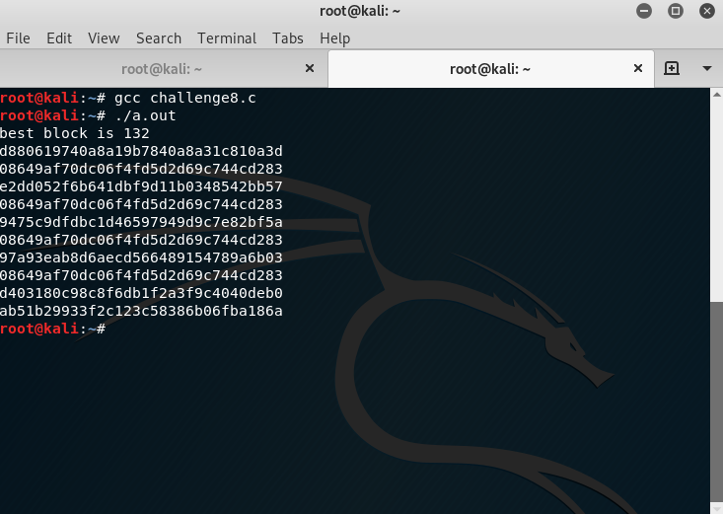

Challenge 1 out of 5

PART -2

# **Challenge 1:Hash - Message Digest 5**

#### **Statement**

Crack the following hash :

7ecc19e1a0be36ba2c6f05d06b5d3058

**Solution:**

To get the hash password I used online tool named as Md5() Encrypt &Decrypt

Link of the tool : <https://md5decrypt.net/en/>

Step 1: Copy the hash you want get the password

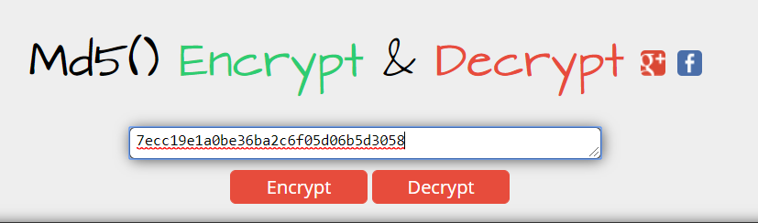

Step 2: Then Click on Decrypt. After Decrypting screen showed

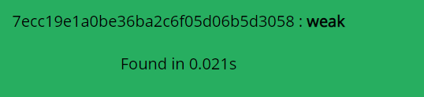

Step 3:Enter the password : weak

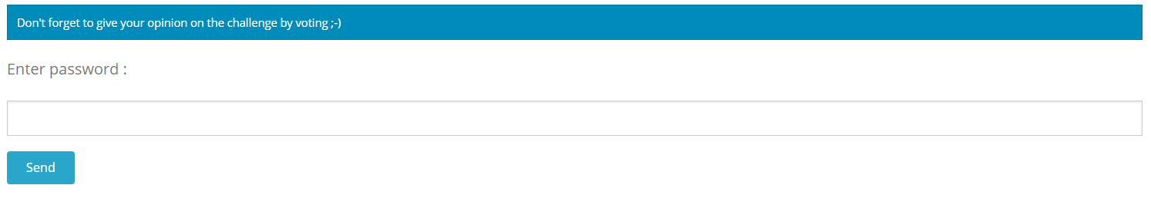

Result

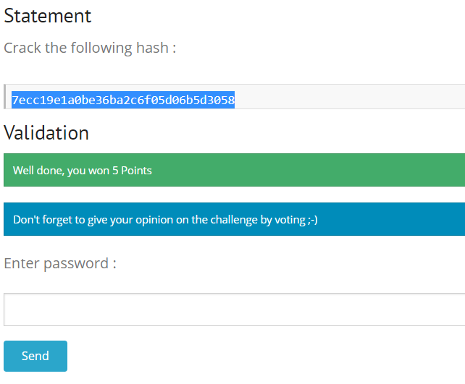

# Challenge 2 out of 5

# **2.Hash - SHA-2**

#### **Statement**

This hash was stolen during a session interception on a critical application, errors may have occurred during transmission. No crack attempt has resulted so far; hash format seems unknown. Find the corresponding plaintext.

96719db60d8e3f498c98d94155e1296aac105ck4923290c89eeeb3ba26d3eef92

The answer is the SHA-1 of this password.

Solution:

Since the given key hash have errors let’s identify the errors.

Calculate the length of hash

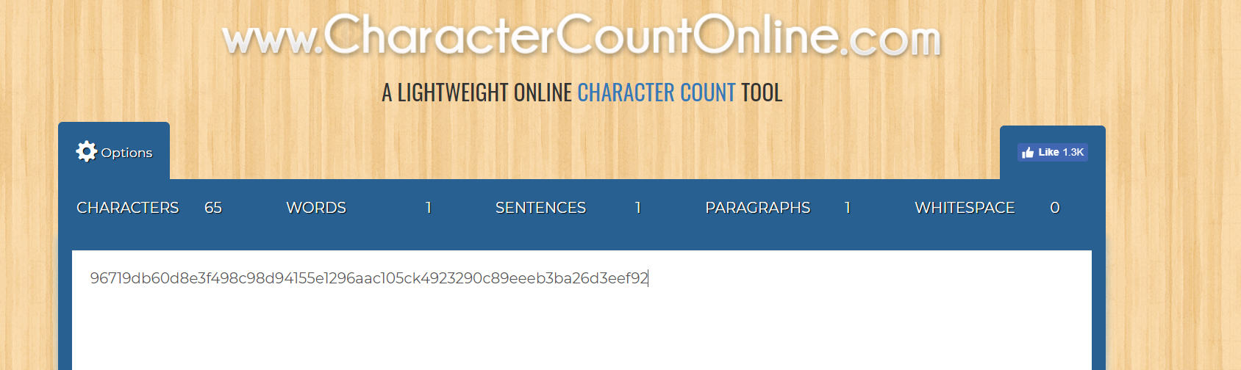

Total no of characters are 65 to nearest SHA-256 and hexadecimal string 64 character long

The characters that sha-256 include ABCDEFGH

So if see the hash 96719db60d8e3f498c98d94155e1296aac105ck4923290c89eeeb3ba26d3eef92

The hash has “k” extra so now corrected hash –

96719db60d8e3f498c98d94155e1296aac105c4923290c89eeeb3ba26d3eef92

Now go to kali linux terminal

Type the command- **hash-identifier**

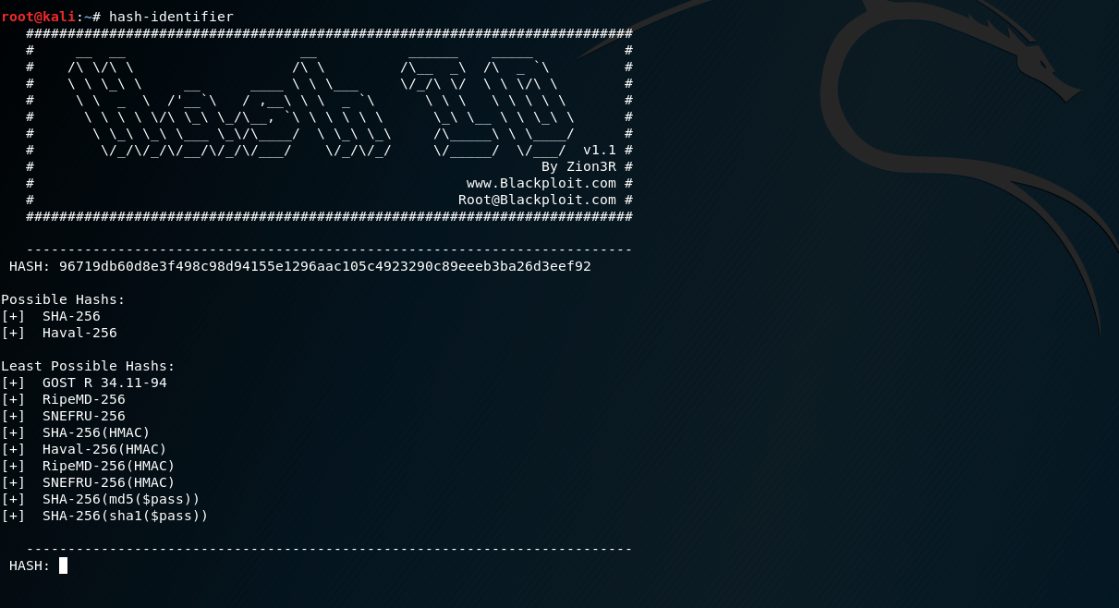

Let try for hash-256

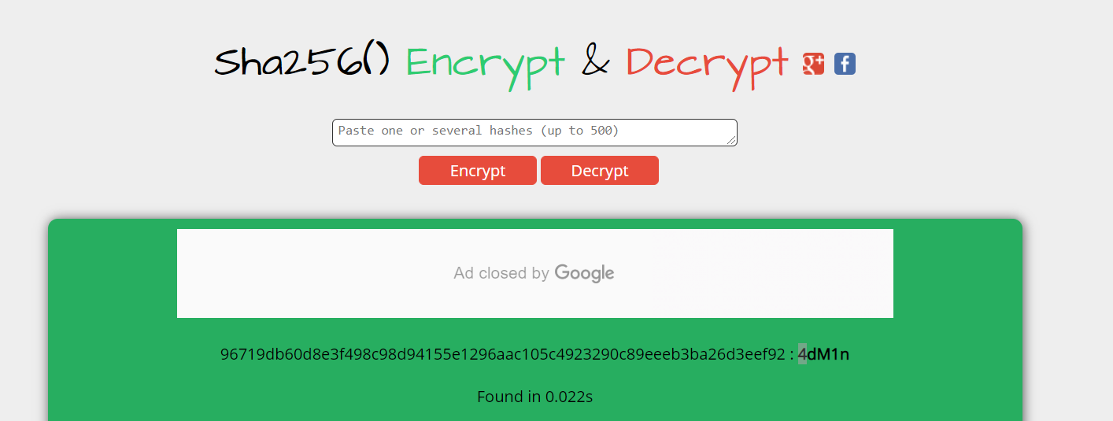

Since the password is SHA-1.

Encrypt “4dM1n” in SHA-1 by encrypter

After encryption we get “**a7c9d5a37201c08c5b7b156173bea5ec2063edf9”**

**Now enter this as password:**

